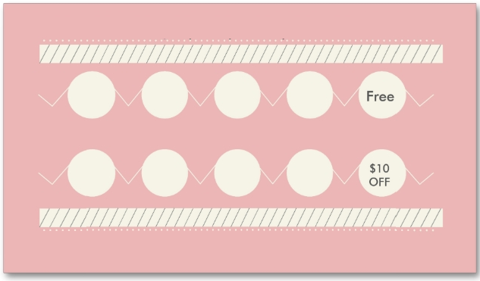

LOGO

LOGO

LOGO

LOGO

Free

Free

Free

Free

Address: Street City Phone# 00112233

Company Name