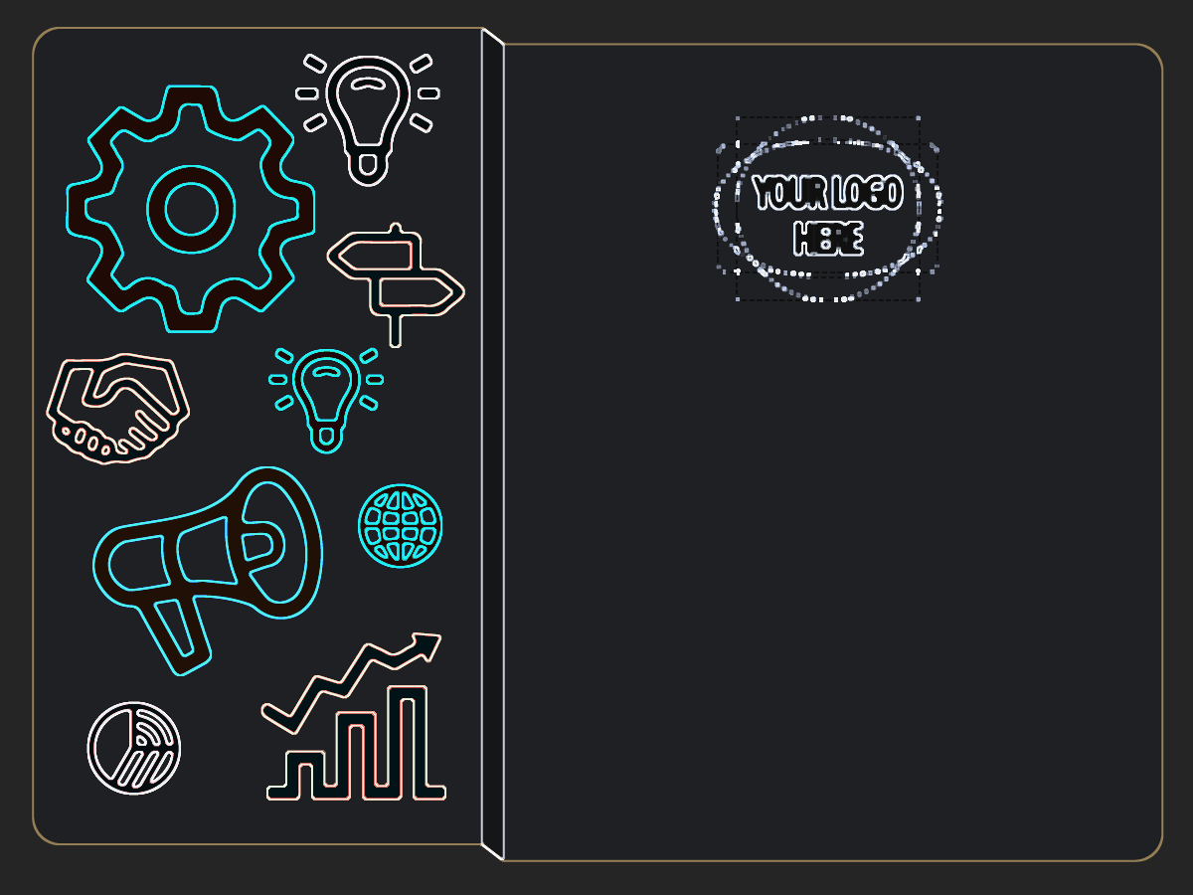

Edward
Edward Michelle

Event name
Attendee

