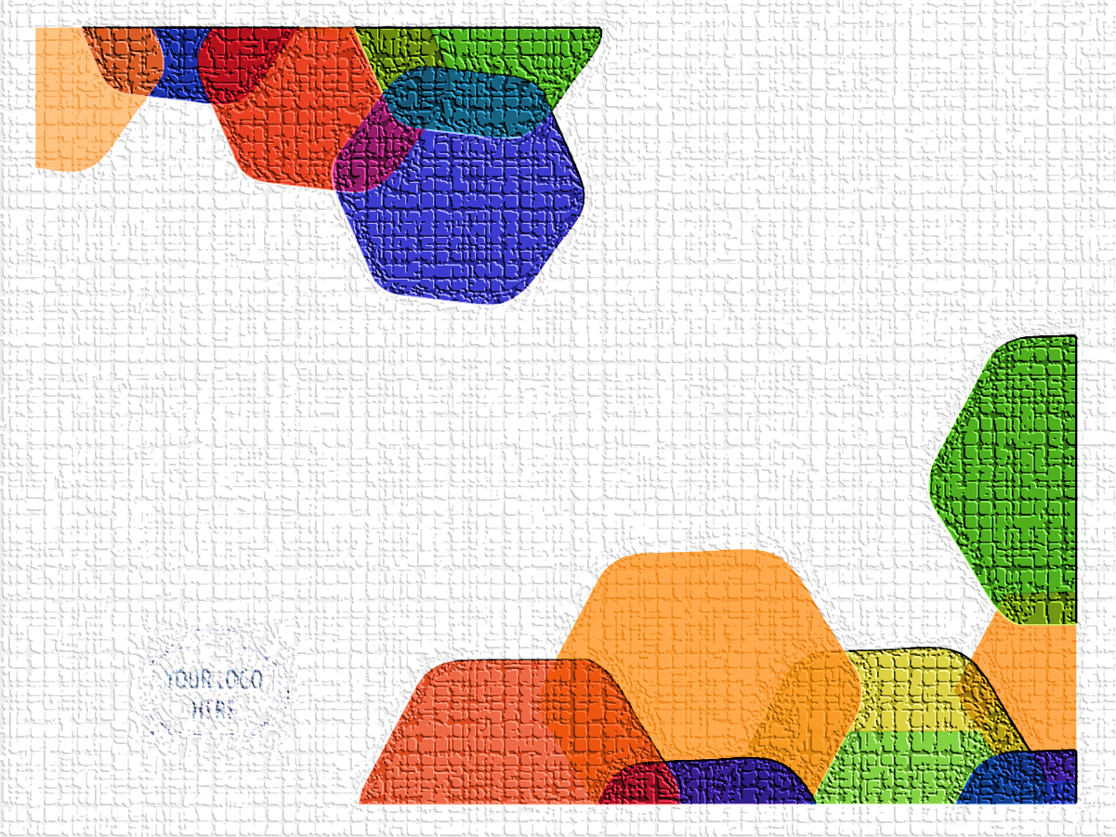

EVENT NAME

Edward
Edward Michelle
Marketing

